**Quarterly Report – Public Page**

**Date of Report:** 1st Quarterly Report - February 1, 2023

**Contract Number:** *693JK32210015POTA*

**Prepared for:** *DOT-PHMSA*

**Project Title:** *Dynamic Geohazard Risk and Decision Support Platform*

**Prepared by:**  *Boston Geospatial, Inc.*

**Contact Information:**  *Justin Oliveira,* [*justin@bostongeospatial.com*](mailto:justin@bostongeospatial.com)*, 781-975-3748*

**For quarterly period ending:** *December 31, 2022*

**1: Items Completed During this Quarterly Period:**

| ***Item #*** | ***Task #*** | ***Activity/Deliverable*** | ***Title*** |
| --- | --- | --- | --- |
| 1 | 1.1 | Acceptable Limits Module | Identify relevant limit equations for design in environments w/ seismic, subsidence, and slip/fault loading; Establish parameter-based tree diagrams to direct equation usage |
| 2 | 0.1 | 1st Quarterly Status Report | Submit 1st quarterly report |

**2: Items Not-Completed During this Quarterly Period:**

No incomplete invoiceable items this quarter. Overall our project is mostly on schedule - we are really only behind at this point on non-invoiceable work relating to assembling our academic TAP. If after academic TAP finalization there are revisions recommended to any of the design limit equations, we will have sufficient time and resources to reach a consensus between any academic TAP member and our SME. The same is true near the end of the project when the formal review by the academic TAP is conducted - the schedule and project plan leaves for adequate time to make adjustments. A key piece of the work being done under Task 1 is just laying out the groundwork and foundation to connect design code and equations to determinants in a geohazard platform. We anticipate over time that both regulatory requirements, best-practice guidelines, and design limit equations will change, therefore a key part of the work being done in this project is the development of a framework that can be reused in the future to make this tool (and other tools) remain relevant.

**3: Project Financial Tracking During this Quarterly Period:**

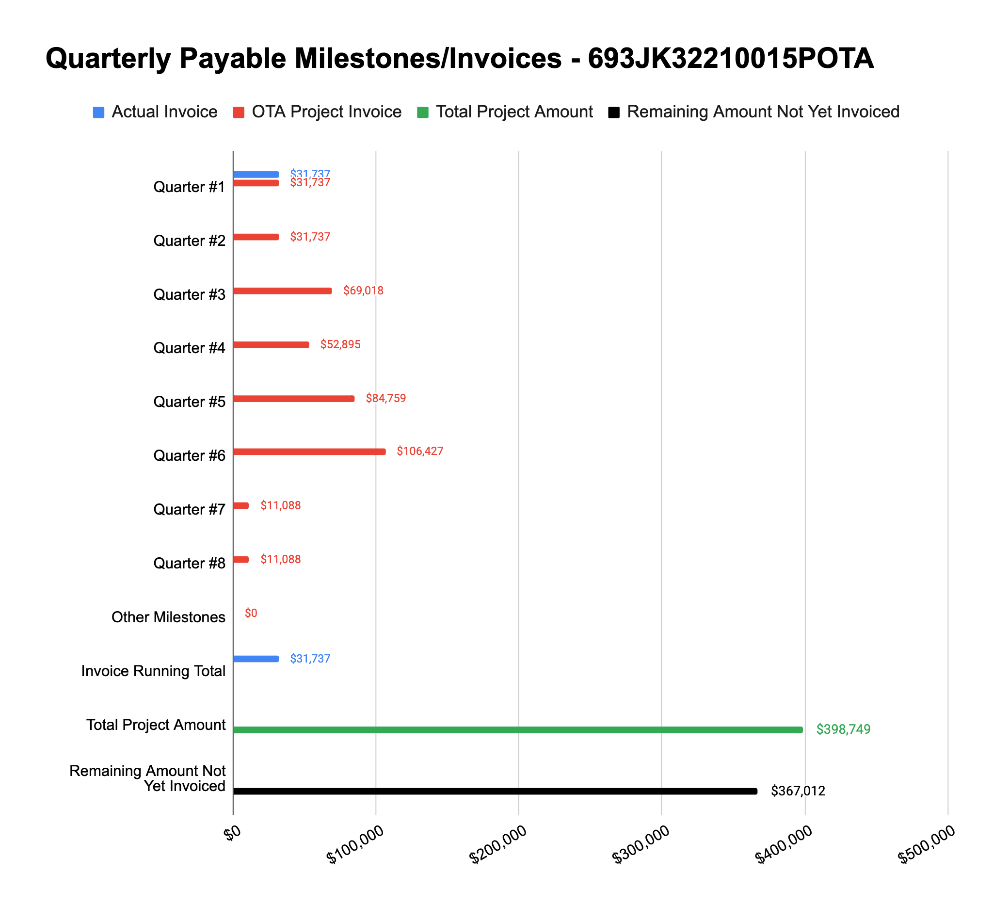

**4: Project Technical Status –**

**Item# 1 / Task# 1.1/ Acceptable Limits Module / Identify relevant limit equations for design in environments w/ seismic, subsidence, and slip/fault loading; Establish parameter-based tree diagrams to direct equation usage**

Work has progressed well on the Acceptable Limits Module work. In working with an external SME (Jeff Suhey - Continuum Engineering), we have reviewed 49 CFR 191, 192 and 195 and cross referenced all sections believed to directly or indirectly relate to geohazards.

Regarding piping design, geohazards are mentioned directly and indirectly throughout CFR 191, 192, and 195.

* Gas Pipelines
  + Earth movement (non-landslide) - e.g. subsidence or heaving - indirect requirement through 192.103 with no pointer to external best practice however we’ve used ASME B31.8 (841.13a is the relevant subsection)
  + Landslide - indirect requirement through 192.103 with no pointer to external best practice however we’ve used ASME B31.8 (841.13a is the relevant subsection)
  + Seismic (shake load) - indirect requirement through 192.103 with no pointer to external best practice however we’ve used ASME B31.8 (841.13a is relevant subsection)
  + Ground faulting - indirect requirement through 192.103 with no pointer to external best practice however we’ve used ASME B31.8 (841.13a is the relevant subsection)
* Liquid Pipeline
  + Earth movement (non-landslide) - e.g. subsidence or heaving - indirect requirement through 195.110 with a pointer to ASME B31.4 (401.2.2.6 is the relevant subsection)
  + Landslide - indirect requirement through 195.110 with a pointer to ASME B31.4 (403.6.2.5 is the relevant subsection)
  + Seismic (shake load) - indirect requirement through 195.110 with pointer to ASME B31.4 (403.6.2.6 is the relevant subsection)
  + Ground faulting - indirect requirement through 195.110 with pointer to ASME B31.4 (403.6.2.6 is the relevant subsection)

From that research, we created an initial design equation archive for geohazard load cases (e.g. seismic, faulting, subsidence, landslide, etc.) using stress formulas from textbooks or cited ASCE proceedings. The archive includes any associated conditional questions tied to the design equation (e.g. Does the material have a tested [yield strength] value, or no tested value?) that will be required in the code implementation. Each equation also includes a breakdown of the required variables and any empirical values associated with them (e.g. seam joint factor, which will depend on the weld type).

The geohazard load cases as well as nominal load cases (e.g. hoop stress from internal pressure, thermal stress, etc.) will be combined using the ASME maximum distortion energy approach. For pipe under part 192 this is covered in ASME B31.8 833.3, 833.4, 833.5, and 833.6 - similarly, for pipe under part 195 this is covered in ASME B31.4 402.7.

These equations and the connected dependant variables as well as the decision trees will be documented in the Submit Design Code Acceptable Limits Documentation provide in Q2 (Item# 4/Task# 1.3). Based on the work completed thus far, we continue to feel confident that the equations can be curated into a software library and used in the geohazard tool we seek to develop - and we think as these equations either change with time or new/better best practices emerge, the library can be updated fairly easily.

**Item# 2 / Task# 0.1/ 1st Quarterly Status Report / Submit 1st quarterly report**

Additional detail not necessary - this report constitutes the deliverable for Item# 2 / Task# 0.1

**5: Project Schedule –**

Overall our project is mostly on schedule - we are really only behind at this point on non-invoiceable work relating to assembling our TAP.